
Commonwealth of Virginia
Department for Aging and Rehabilitative Services
2001 Maywill Street
Suite 202
Henrico, VA 23230


1610 Forest Avenue, Suite 100
Henrico, Virginia 23229
804-662-9154

Assistive Technology Options to Address Wandering

Here are some strategies from the National Institute on Aging

https://www.nia.nih.gov/

- Make sure the person carries some kind of ID or wears a medical bracelet. If the person gets lost and can’t communicate clearly, an ID will let others know about his or her illness. It also shows where the person lives.
- Consider enrolling the person in a program that will alert you if they wander.
- Let neighbors and the local police know that the person with Alzheimer’s tends to wander. Ask them to alert you immediately if the person is seen alone and on the move.
- Place labels in garments to aid in identification.
- Keep an article of the person’s worn, unwashed clothing in a plastic bag to aid in finding him or her with the use of dogs.
- Keep a recent photograph or video recording of the person to help police if he or she becomes lost.

Tips to Prevent Wandering
Here are some tips to help prevent the person with Alzheimer’s from wandering.
- Keep doors locked. Consider a keyed deadbolt, or add another lock placed up high or down low on the door. If the person can open a lock, you may need to get a new latch or lock.*
- Use loosely fitting doorknob covers so that the cover turns instead of the actual knob.*
- Place STOP, DO NOT ENTER, or CLOSED signs on doors.
- Divert the attention of the person with Alzheimer’s disease away from using the door by placing small scenic posters on the door; placing removable gates, curtains, or brightly colored streamers across the door; or wallpapering the door to match any adjoining walls.
- Install safety devices found in hardware stores to limit how much windows can be opened.
- Install an “announcing system” that chimes when a door is opened.
- Secure the yard with fencing and a locked gate.
- Keep shoes, keys, suitcases, coats, hats, and other signs of departure out of sight.
- Do not leave a person with Alzheimer’s who has a history of wandering unattended.

Possible Assistive Technology to help people keep track of their things or within their home:

 | AirTag - Apple  AirTag is a super easy way to keep track of your stuff. Attach one to your keys. Put another in your backpack. And just like that, they’re on your radar in the Find My app, where you can also track down your Apple devices and keep up with friends and family.  www.apple.com  AirTag was designed to help people locate their personal belongings, not to track people or another person's property.

Apple Airtag holders: key chains, hidden clothing holders wallet / creditcard size holders are available on Amazon and other websites. Airtags need nearby iPhones in order to work and the range to receive a signal may be limited.

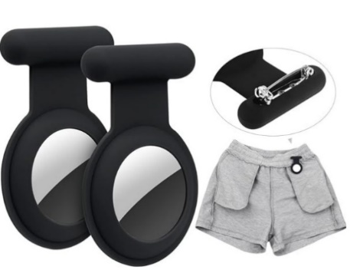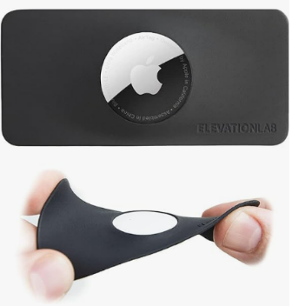

Cell phones, apps and Smart Watches may also be useful.

There are also several door chimes, mats and motion detection chimes that can send out an alarm on a wearable device or one that is plugged in. These are only useful in the home.

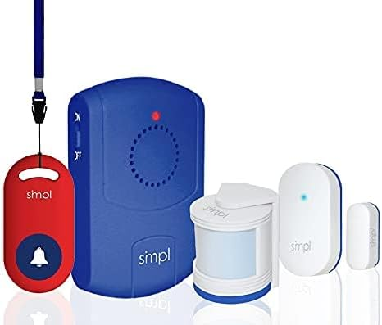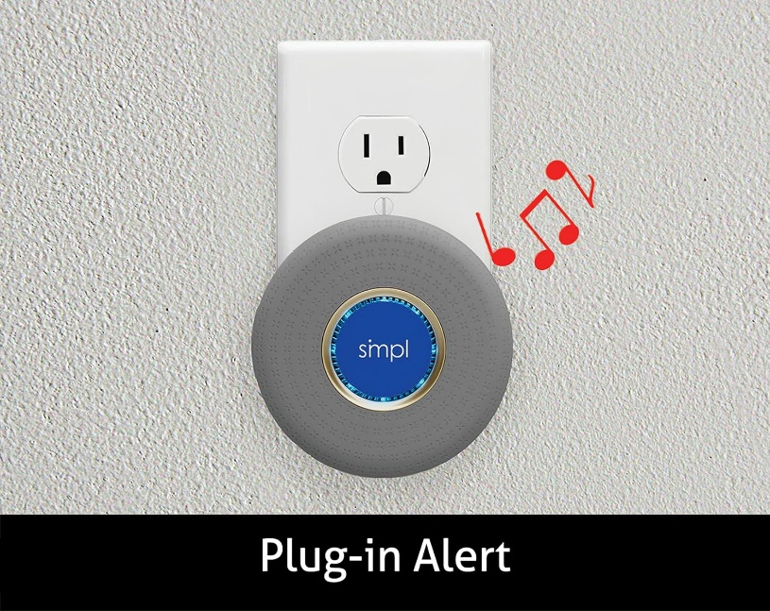

https://smpltec.com/alerts/

Wearable GPS Trackers

There are several options on the market. You can look up “Wearable GPS Trackers” and research what would work best for you but here are a few suggestions. We recommend speaking directly with your primary care provider to review the necessary precautions if you have a pacemaker with any other electronic device containing radios.

Project Lifesaver

“Project Lifesaver is the premier search and rescue program operated internationally by public safety agencies, and is strategically designed for “at risk” individuals who are prone to the life threatening behavior of wandering. The primary mission of Project Lifesaver is to provide timely response to save lives and reduce potential injury for adults and children with the propensity to wander due to a cognitive condition.”
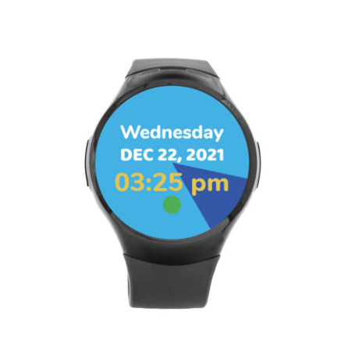
1-800-580-LIFE

https://projectlifesaver.org/

AngelSense
https://www.angelsense.com/
AngelSense is designed for individuals with autism, special needs, Alzheimer’s and dementia. It includes an AI-powered monitoring & alerting system, an app for multiple caregivers and a device of your choice, with an auto-pickup speakerphone.
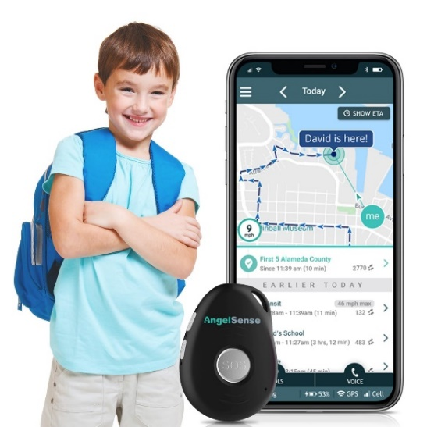

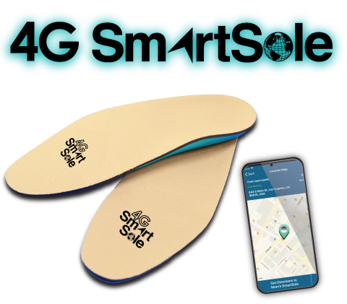 | GPS SmartSole  The Award Winning, Multi-Patented, World's First Hidden Wearable GPS Tracking Solution for Those Who Wander. SmartSole® is a GPS tracker hidden and sealed within a water-resistant shoe insert. THE KEY ADVANTAGE: SmartSole® is discreet and your loved one won’t forget to bring it with them!  www.gpssmartsole.com
Check coverage in your area.

Physical Barriers
Until a fence can be installed, a temporary idea is to put up an inexpensive construction material fence to help keep the person who is wandering nearby. This comes in rolls of several heights & lengths and not very expensive. It's fast & easy to work with. It can even be stretched between existing trees and stapled to them.

This can be purchased at hardware stores, Amazon, etc.


Other Helpful Resources:

Virginia No Wrong Door – Easy Access – internet based supportive community and resources!
https://easyaccess.virginia.gov/

211 is a vital service that connects millions of people to help every year. Simply dial 211 on your phone!

Center for Family Involvement
CFI is part of the Partnership for People with Disabilities at VCU. They have a network of staff and volunteer Family Navigators who have lived experience and provide one to one emotional, informational and systems navigational support for individuals with disabilities and their family members. For more information and assistance on a wide variety of resources. Call the Helpline (877) 567-1122 or email cfihelpline@vcu.edu.

For more information about a low interest loan that is available through ATLFA contact:

Assistive Technology Loan Fund Authority
www.atlfa.org

Phone: 804-662-9000
Toll Free: (866) 835-5976
Email: atlfa@atlfa.org

Address: 1602 Rolling Hills Drive, Suite 107
Richmond, VA 23229

For More Suggestions, check out this Home Safety Checklist:

Dementia Capable Virginia Home safety information toolkit for dementia

Home Safety Checklist

Tips from Autism Speaks:

www.autismspeaks.org

Wandering Prevention Tips

Info on Sensory Gyms:

https://www.royaltysensorygyms.com/

7 Steps to Help Prevent Children with Autism from Wandering

The resources provided are for informational purposes only. None of the authors, employees, agents, contractors, or representatives of the Commonwealth of Virginia, Department for Aging and Rehabilitative Services, and/or the Virginia Assistive Technology System, can be responsible for your use of the information contained in or linked to this resource document. Phone numbers and addresses may change without notice. Thank you!

