VATS / NWD Emergency Preparedness Kit Guidebook:
Welcome to your Emergency Preparedness Kit! As you know, being prepared can help reduce fear and anxiety. The Red Cross recommends: get a kit; make a plan; and be informed. Click Here or
https://www.redcross.org/get-help/how-to-prepare-for-emergencies

The purpose of this Kit is to demonstrate a few affordable and user-friendly technologies and assistive technology devices that can help older adults and Virginians with disabilities plan for plan for and develop their own emergency kit. This is not an exhaustive list, and welcome you to add more items based on constituent feedback. We hope that by providing you with these devices and this Guidebook, that it will help start the conversation and encourage families / individuals to make and personalize their own kits!
Most of the items in this Kit are readily available, consumer products versus specialty items and can be purchased locally or online from a variety of retailers. VATS does not endorse one brand over another. Items in this Kit are meant to have people think about their needs and prepare for the unexpected. For example, plug in emergency flashlights are sold under numerous brand names. What is important is to have a charged flashlight when the lights go out! The costs listed are estimates.

Items in this Kit remain the property of VATS, but housed and maintained with your organization. No need to “check in/out” this Kit from VATS, it will be readily available at your site(s) for demonstration (Lunch & Learn, trainings, conferences, meeting 1:1 with individuals etc.). Please identify / designate an individual to maintain the equipment (charging items, checking functionality periodically etc.) and collect / provide data to VATS to demonstrate client demand.

If you have any questions, please contact:

Paula Martin: Paula.Martin@dars.virginia.gov or
VATS Central: (804) 662-9990, www.vats.org
Here is a list of additional items that are not in the Kit but may be beneficial:
Medical Items:
- Cooler / Ice Packs (For Medication Needing Refrigeration)
- Ice Packs
- List of meds and extra meds
- Face mask
- Extra batteries
- Gloves
- Hand sanitizer
- Germicidal wipes
- Assorted bandages, antiseptics
- Personal care items
- List of health care providers and emergency contacts and family / friends
  - Check online - lots of good examples
  - Emergency Contact Card
    - Click Here or
https://www.redcross.org/content/dam/redcross/get-help/how-to-prepare/253901-07%20BRCR%20Emergency%20Contact%20Card%20FINAL.pdf
  - ..Red Cross Emergency Preparedness
    - Click Here or
https://www.redcross.org/content/dam/redcross/get-help/how-to-prepare/Older_Adults_Disaster_Prep_1Pager_07272020.pdf
Additional Suggestions for the kitchen:
- Cooler / Ice Packs
- Cans and packaged food (canned meat and veggies)
- Bottled water
- Peanut butter
- Powdered milk
- Sharpie or labels to mark dates of expiration on food items
- Instant coffee!
- Pet food
- Extra AA and AAA Batteries and manual can opener
All items below can be purchased from Amazon
Emergency Preparedness Kit Items:
General Safety
- Plug In / Rechargeable Emergency Flashlight - $12
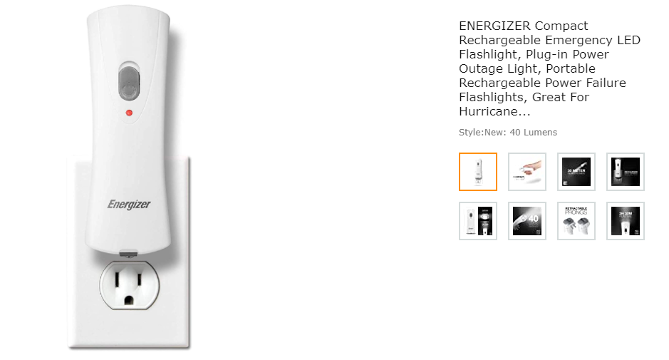

- Emergency Radio, flashlight, smartphone charger and red beacon - $50
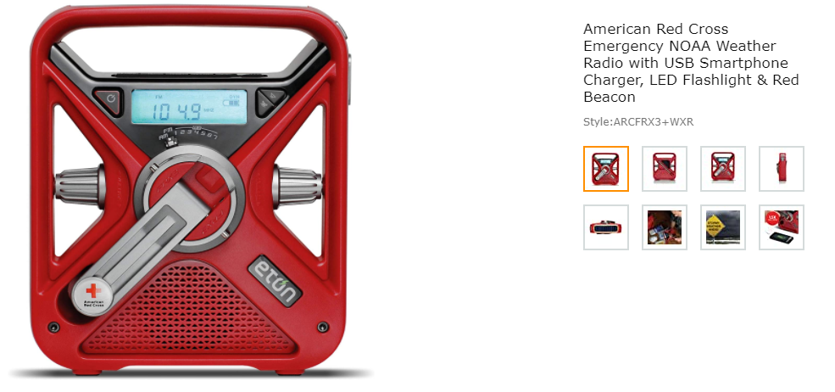
- Solar Charger Power Bank - $25
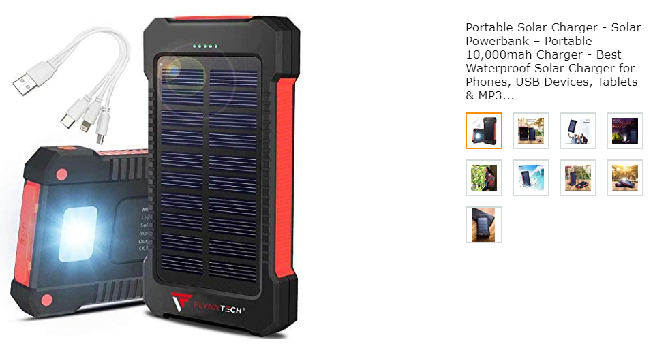
- Safety Whistle - $3
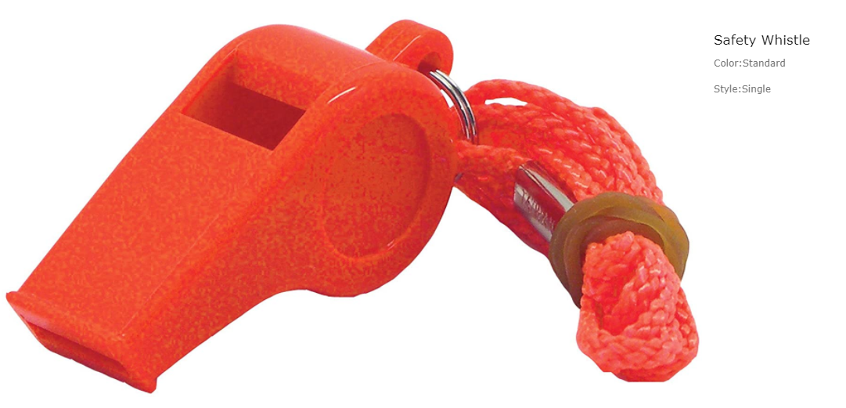

- Folding Cane - $16
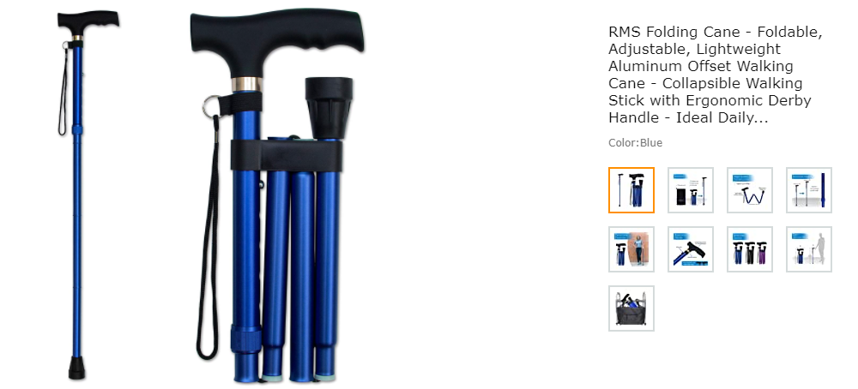
- Touchless Forehead Thermometer - $20

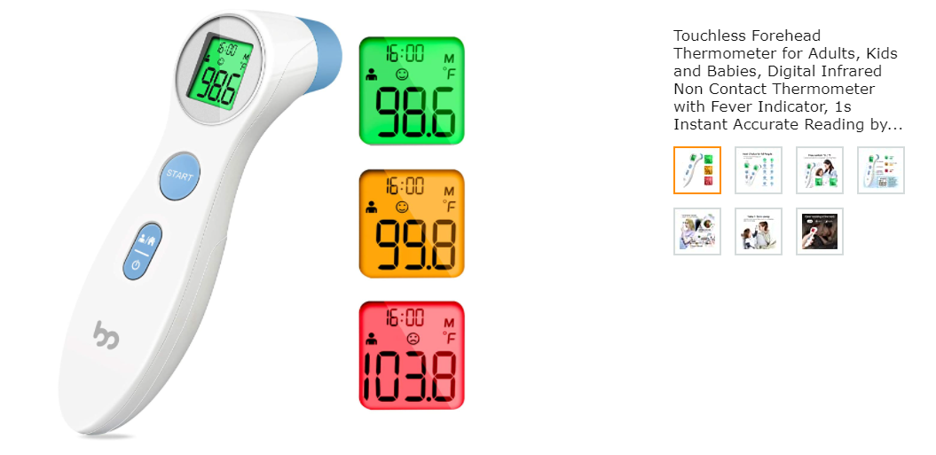

Food Safety
- Battery Operated Can Opener - $20
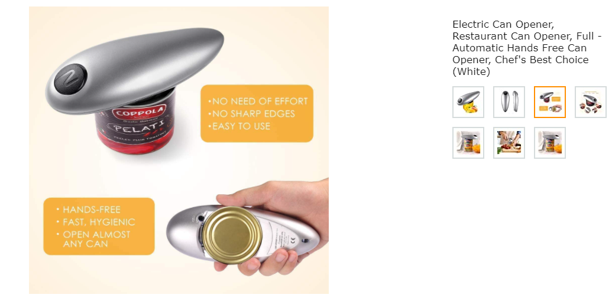

- Kitchen Helper Jar and Bottle Openers - $10
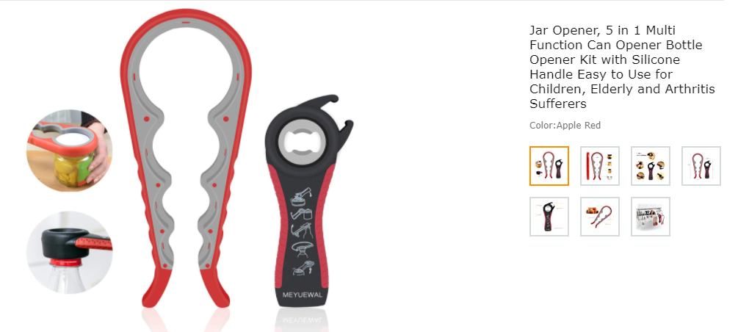

- Spring Loaded Easy Action Shears - $20



Pet Supplies – storage container - $12

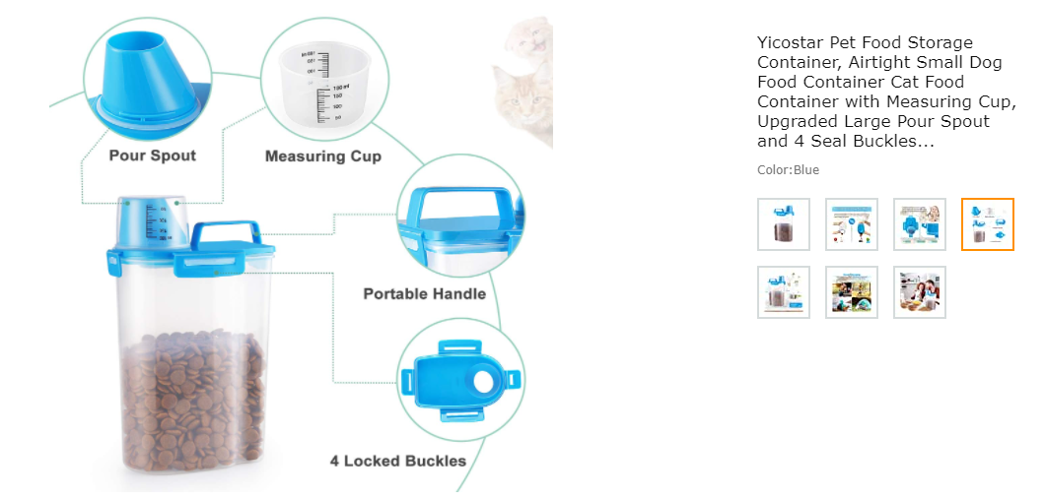

Emergency Preparedness Kit Additional Videos

Plug in/Rechargeable Battery Flashlight: Click Here or

https://www.youtube.com/watch?v=XYfAPMxM5PE

Notes:
- Technically a review and not the most professional, but he covers how it works and how to use it.

Emergency Radio, flashlight, smartphone charger and red beacon: Click Here

https://www.youtube.com/watch?v=70uVpx6AAvM

Notes:
- Professionally made and covers each of the features.

Solar Charger Power Bank: Click Here

https://www.youtube.com/watch?v=J-Yd8msawqY

Notes:
- Review, but professional and mentions all of the features and highlights in clear language.

Foldable Cane

https://www.youtube.com/watch?v=df6aNK57Aa8

https://www.youtube.com/watch?v=aCZHU_BLE0E

Notes:
- First was produced by the manufacturer. Demonstrates use but does not explain.
- Second is more thorough but uses a different company’s cane (with the same design).

Touchless Forehead Thermometer

https://www.youtube.com/watch?v=SSACsLrUHyQ

Notes:
- Professional, helpful tutorial with application.
Battery Operated Can Opener

https://www.youtube.com/watch?v=95QMev6mbc0

Notes:
- Made by the manufacturer. Does not provide step by step instruction, rather, it displays how to use.

Kitchen Helper Jar and Bottle Opener

https://www.youtube.com/watch?v=pMt7bTOUFKs

Notes:
- Not very professional- personal review of several products. Shows how to use. Helpful tips.

