Get Started
Request Case Management Services
Thank you for your interest in DARS. By completing this referral form, you’re taking the first step toward exploring case management supports through the Long-Term Rehabilitation Case Management programs.
If you have a documented disability that includes one of the following traumatic brain injury, spinal cord injury, cerebral palsy, arthritis, muscular dystrophy,
multiple sclerosis, prader willi or systemic lupus, you may qualify for coordination supports.
What to Expect:
- Complete the form so we can assess your eligibility for coordination support.
- A staff member will contact you to schedule a conversation about your coordination needs and you are welcome to invite a friend or family member to join the call
To be eligible for LTRCM services, all of the following must apply:
- You are a Virginia resident
- You have a documented disability as outlined above
- Your disability creates a substantial barrier in three or more areas of your life
- You do not have a case manager/care coordinator from any other source
- You need case management to meet your desired life goals and objectives
Note: Please do not attach any files or documents.
Form results mailed to multiple addresses [NEED EMAILS AND ROUTING INFORMATION]

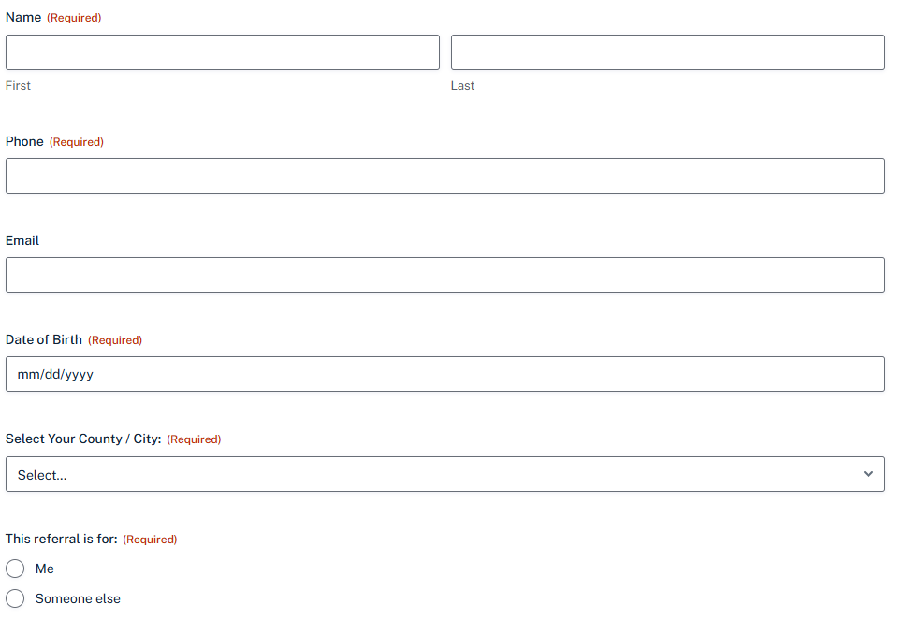
You have a disability in one of the areas identified above
- Yes
- No
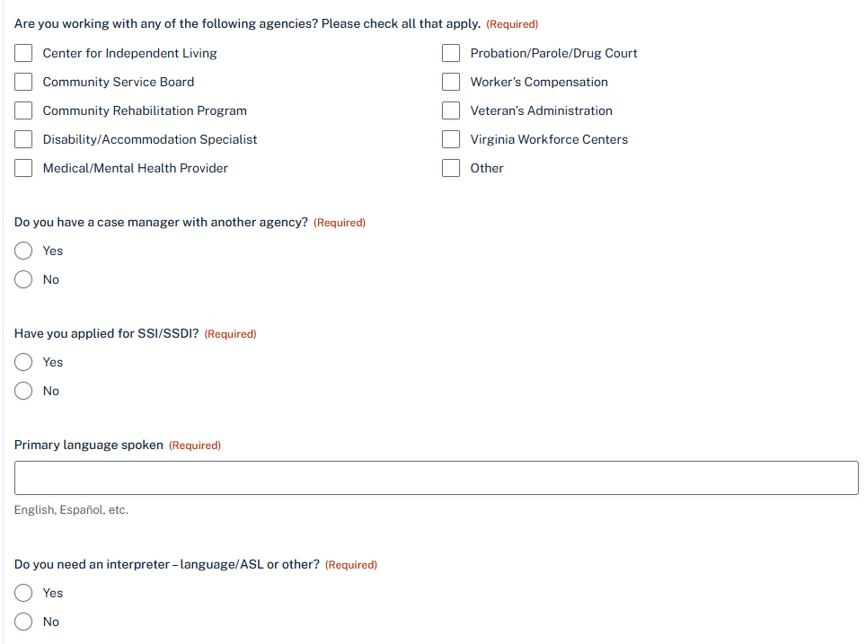

Submit

