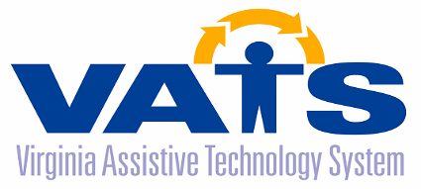

Assistive Technology Advisory Council Meeting
Thursday, May 18, 2023
Department for Aging and Rehabilitative Services
8004 Franklin Farms Drive, Richmond, Virginia 23229
First Floor Conference Rooms 101-105

AGENDA

9:30 AM Networking All ATAC Members

10:00 AM Welcome/Call to Order Joann Lindholm
Theme – Access, Access, Access! (ATAC Chair)

Draft Agenda Review / Additions Joann Lindholm

Review of Draft Minutes from 11/17/22 Joann Lindholm

Public Comments Joann Lindholm

VATS Program Updates Barclay Shepard
- General Updates

Universal Design Project Presentation Scott Pruett
Sarah Pruett
12:00 PM Working Lunch
(Advisory Council Member Updates) All ATAC Members

12:30 Election of Officers Joann Lindholm

Digital Accessibility Training TBA

1:30 VATS Contractor Updates
- CATS John Naples
- F.R.E.E. Robin Ramsey

Next Advisory Council Meeting Joann Lindholm
TBD

2:30 Adjourn

