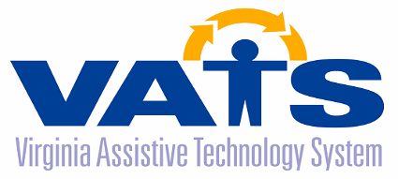

Assistive Technology Advisory Council Meeting
Thursday, November 17, 2022
Department for Aging and Rehabilitative Services
8004 Franklin Farms Drive, Richmond, Virginia 23229
First Floor Conference Rooms 101-105

DRAFT AGENDA

9:30 AM Networking All ATAC Members

10:00 AM Welcome/Call to Order Joann Lindholm
Theme – Connections and Collaborations (ATAC Chair)
Review of Draft Minutes from 5/19/22 Joann Lindholm

Public Comments Joann Lindholm

VATS Director Update Barclay Shepard

No Wrong Door Virginia Presentation Sara Link

Sheltering Arms Institute Presentation Alison Clarke

12:00 Working Lunch
VATS Program Updates
- No Wrong Door Paula Martin
- AT Access & DEI Emily McKeough
- AT & Aging / Reuse Sonja Schaible

12:45 VATS Contractor Updates
- CATS Timp Hecht
- F.R.E.E. Robin Ramsey

VATS Advisory Council Member Updates All ATAC Members

Discuss Officer Elections for next meeting Barclay Shepard

Next Advisory Council Meeting Joann Lindholm
TBD

2:30 PM Adjourn

