Commonwealth Neurotrauma Initiative

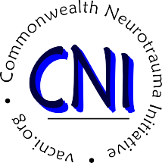

Virginia Department for Aging and Rehabilitative Services
5260 Cox Road
Glen Allen, VA 23060

March Advisory Board Meeting (In-Person)
Friday, March 13, 2026
10:00 AM to 1:00 PM
5260 Cox Road, Glen Allen, VA 23060

June Advisory Board Meeting (Virtual)
Friday, June 12, 2026
10:00 AM to 1:00 PM
Zoom
September Advisory Board Meeting (In Person)
Friday, September 18, 2026
10:00 AM to 1:00 PM
5260 Cox Road, Glen Allen, VA 23060

December Advisory Board Meeting (Virtual)
Friday, December 11, 2026
10:00 AM to 1:00 PM
Zoom
Meetings are open to the public. For additional information or to request meeting materials or accommodations, including ASL interpretation services, please contact Devin Bowers by emailing cni@dars.virginia.gov or calling 804-662-7110.

Meeting materials can also be acquired by visiting https://www.vacni.virginia.gov/.

Public comment will be accepted by email (cni@dars.virginia.gov) or phone (804-662-7110).

Public comments received by 5:00 PM on the Friday before each meeting will be read (or if lengthy, summarized) during the meeting.

